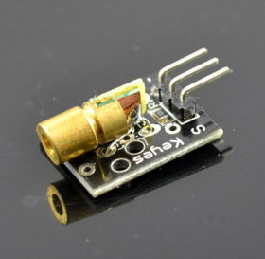
Laser transmitter module can generate laser light. In this project, we will use Arduino, bluetooth sensor and Android cell phone to control laser transmitter. When we type ‘1’ in Android app, the module will send laser, when type ‘0’, the laser will turn off.
Step 1. connect theHC06 bluetooth sensor ,laser module with arduino as per following graph.
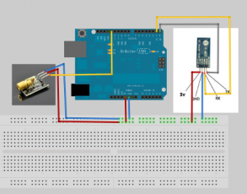
Step 2: if your android device does not have Amarino app, please download Amarino app into your android device. Open the app and search the bluetooth device “HC06″ and pair it with android device. use the default passcode “0000” or “1234”. If you have already installed Amarino app, please skip this step.
Step 3: Download sketch code and load it into arduino.

